

STUDENT DETAILS
JOY NJERI
BBIT/2024/73357
Course: BBIT
BIT3208
Advanced Web Design and Development
Michael Nyoro
Semester 2 year 3

PROJECT DETAILS

NAME: A NOVEL-STORE E-COMMERCE SYSTEM

Technologies: E.g. PHP & MySQL

Online portfolio: https://github.com/joymang84-alt/novel-store

Contents
STUDENT DETAILS 1
PROJECT DETAILS 1
WEEK 1; Installation of XAMPP Control Panel(Apache and MySQL) 3
Hello world test 3
Localhost test page 3
Database Connection Test: 4
WEEK 2; WIREFRAMES AND GUI DESIGN 4
Novels wireframe 4
Dashboard layout design 4
Checkout wireframe 5
Week 3: JavaScript and PHP Basics 5
Fig 1: JavaScript Form Validation 5
5
Fig 2: Password Strength Checker 6
6
Fig 3: PHP Syntax Practice 6
6
Fig 4: Database Connection Script 6
6
Fig 5: Dynamic User Input Handling 7
7
Student reflection: 7
WEEK 4 : 8
Login form screenshots 8
Form validation 8
PHP processing 9
Add novel php 9
Checkout php 9
Database connection 10
10
GIT HUB Repository: Novel-store 10
WEEK 5: Databases: phpMyAdmin tables 11
Database screenshot 11
11
Table creation 11
Novel table 11
order table 12
Users table 12
CRUD OPERATIONS 13
Create 13
Update 13
Login integration 14
Login.php 14
Register.php 14
Sql query 15
users query 15

WEEK 1; Installation of XAMPP Control Panel(Apache and MySQL)

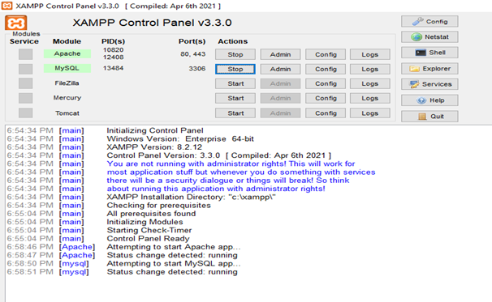

Hello world test

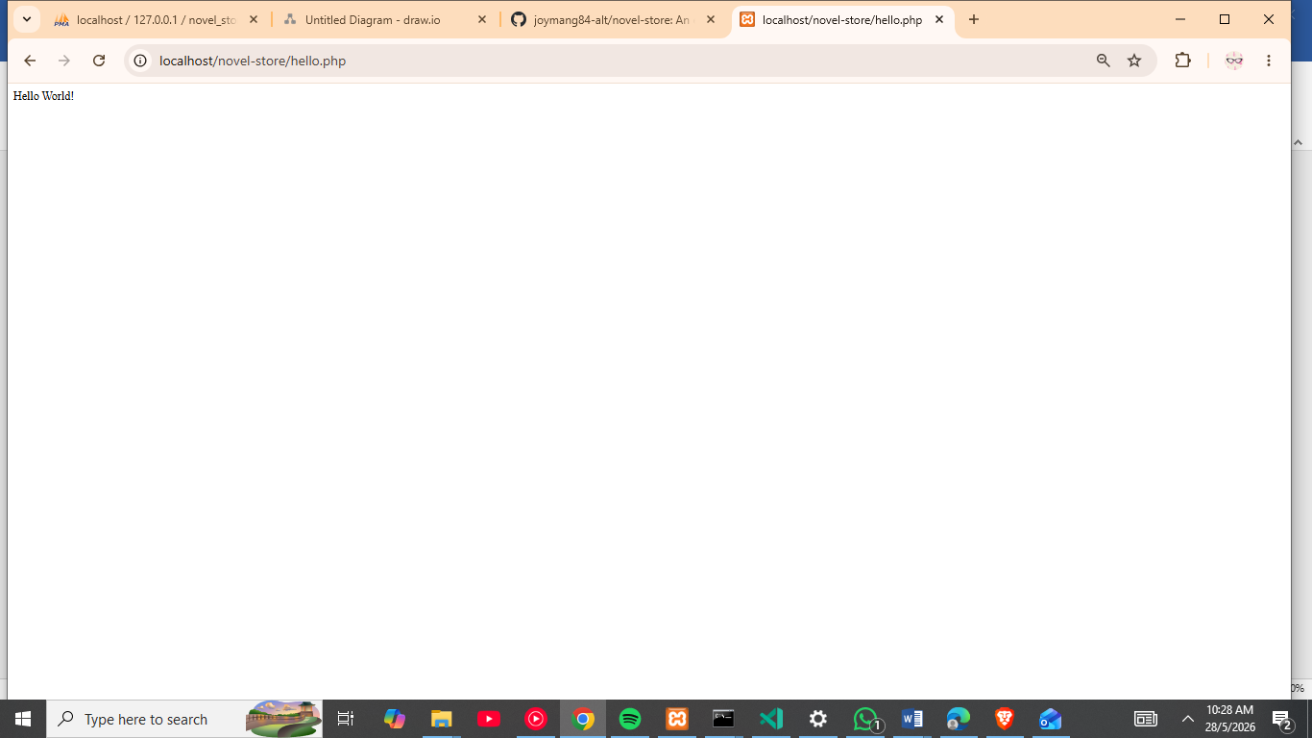

Localhost test page
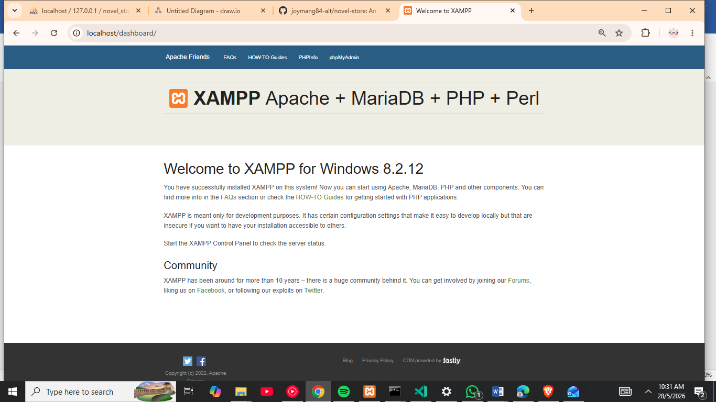

Database Connection Test:
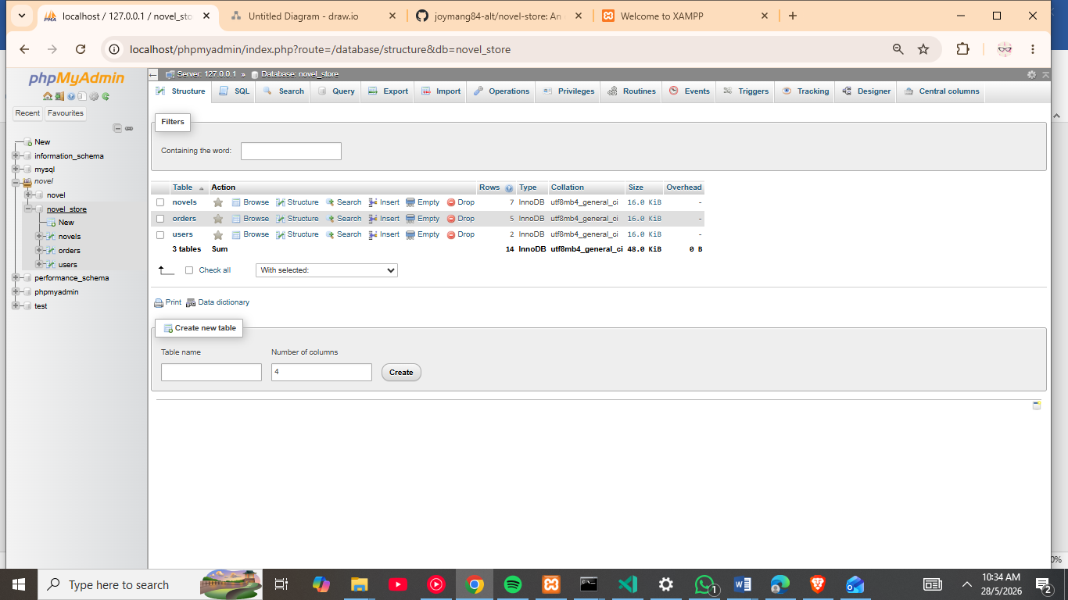

WEEK 2; WIREFRAMES AND GUI DESIGN
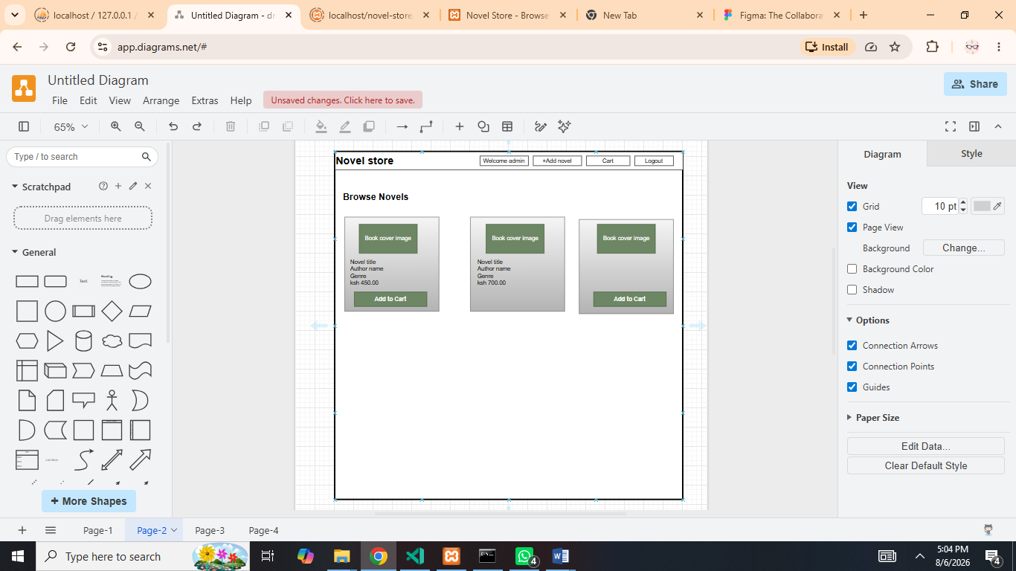

Novels wireframe

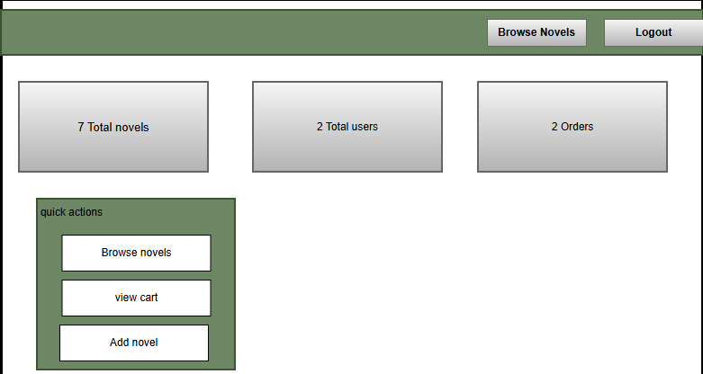

Dashboard layout design

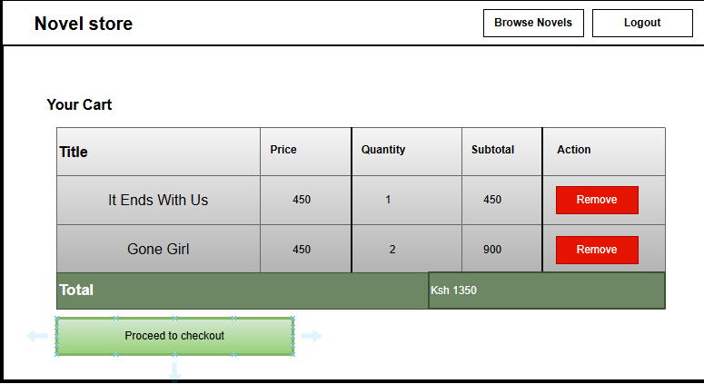

Checkout wireframe

Week 3: JavaScript and PHP Basics

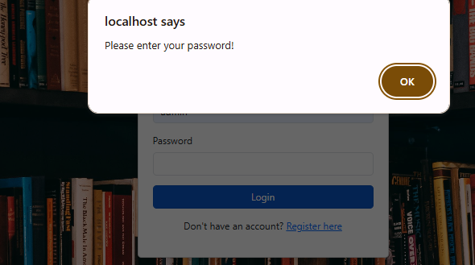
Fig 1: JavaScript Form Validation

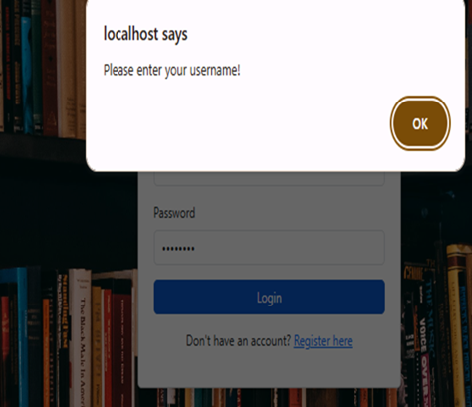

Fig 2: Password Strength Checker

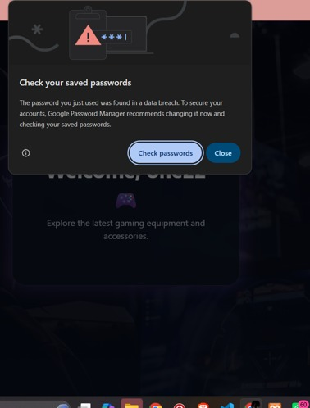

Fig 3: PHP Syntax Practice

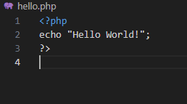

Fig 4: Database Connection Script

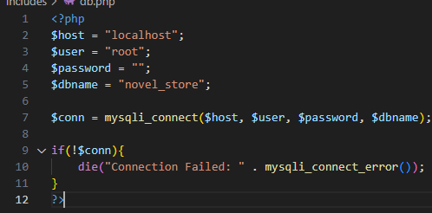

Fig 5: Dynamic User Input Handling

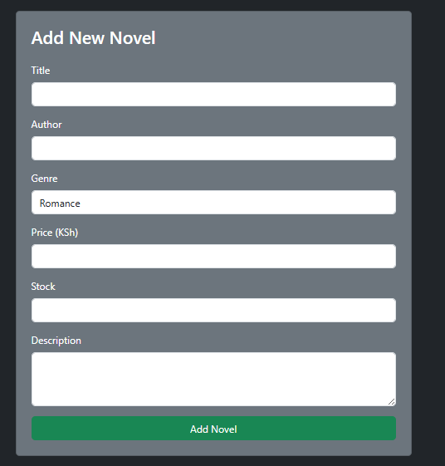

Student reflection:

During the development of the Novel Store Management System, I learned how the frontend and backend work together. The frontend collects user input through forms, while the backend processes the data and communicates with the database. Validation is important because it ensures data is accurate, complete, and secure before being stored. The database connection enables the system to save, retrieve, update, and manage information efficiently. The technologies used in this project include HTML, CSS, JavaScript, PHP, MySQL, and XAMPP.

WEEK 4 :
Login form screenshots
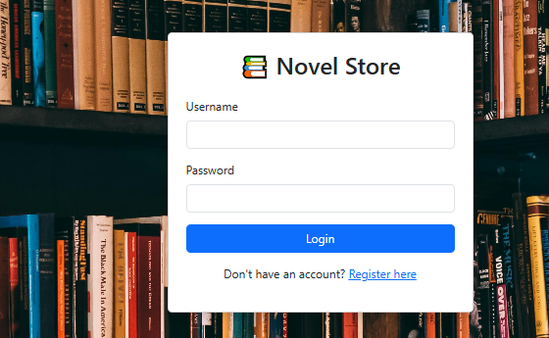

Form validation


PHP processing
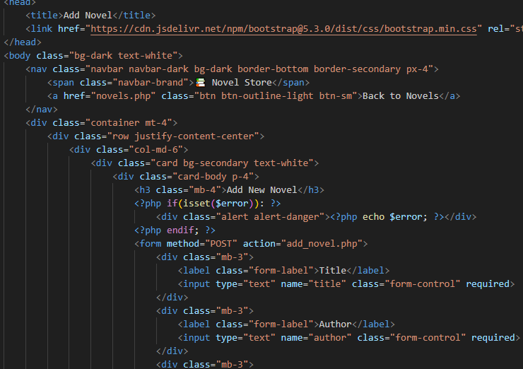

Add novel php

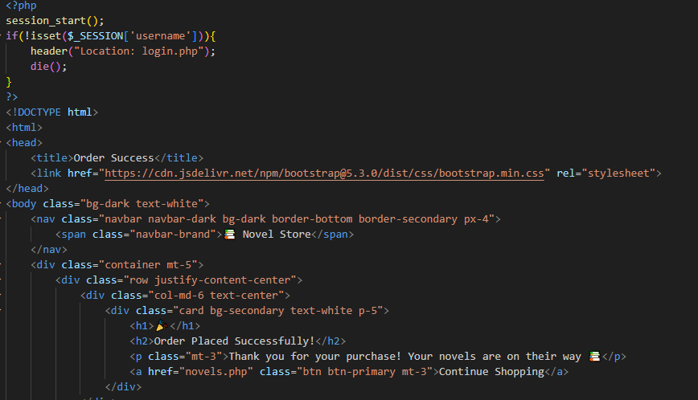

Checkout php

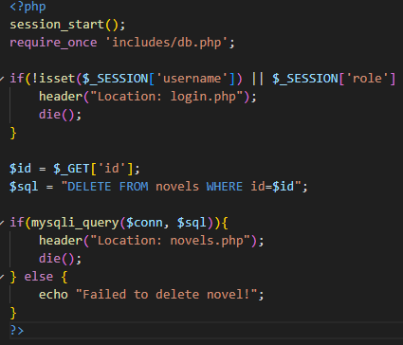 delete php

Database connection

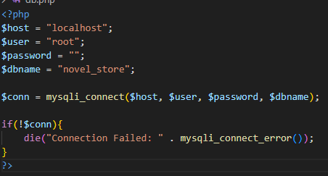

GIT HUB Repository: Novel-store
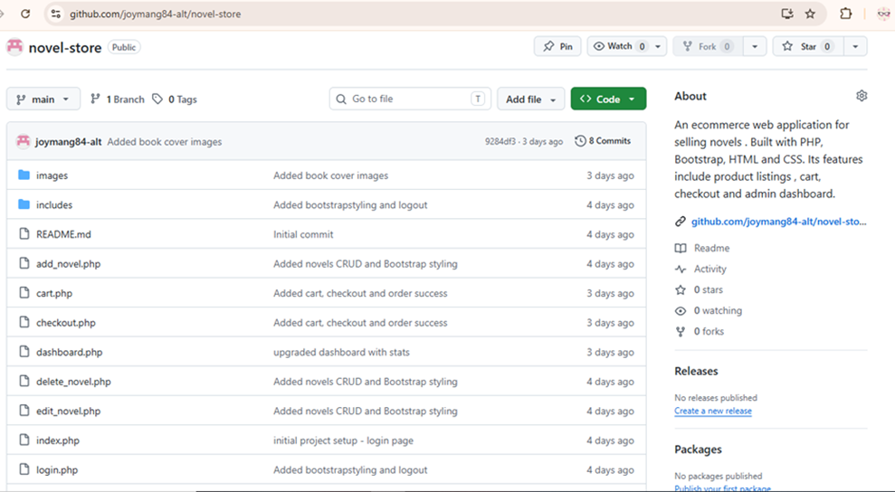

WEEK 5: Databases: phpMyAdmin tables

Database screenshot

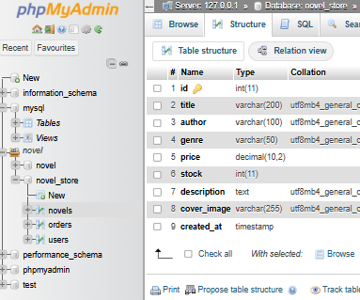

Table creation

Novel table
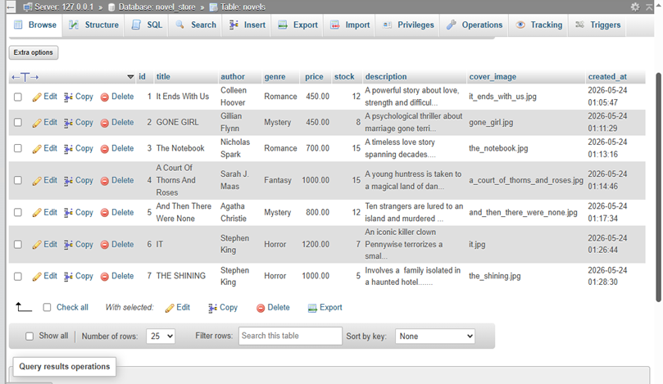

order table
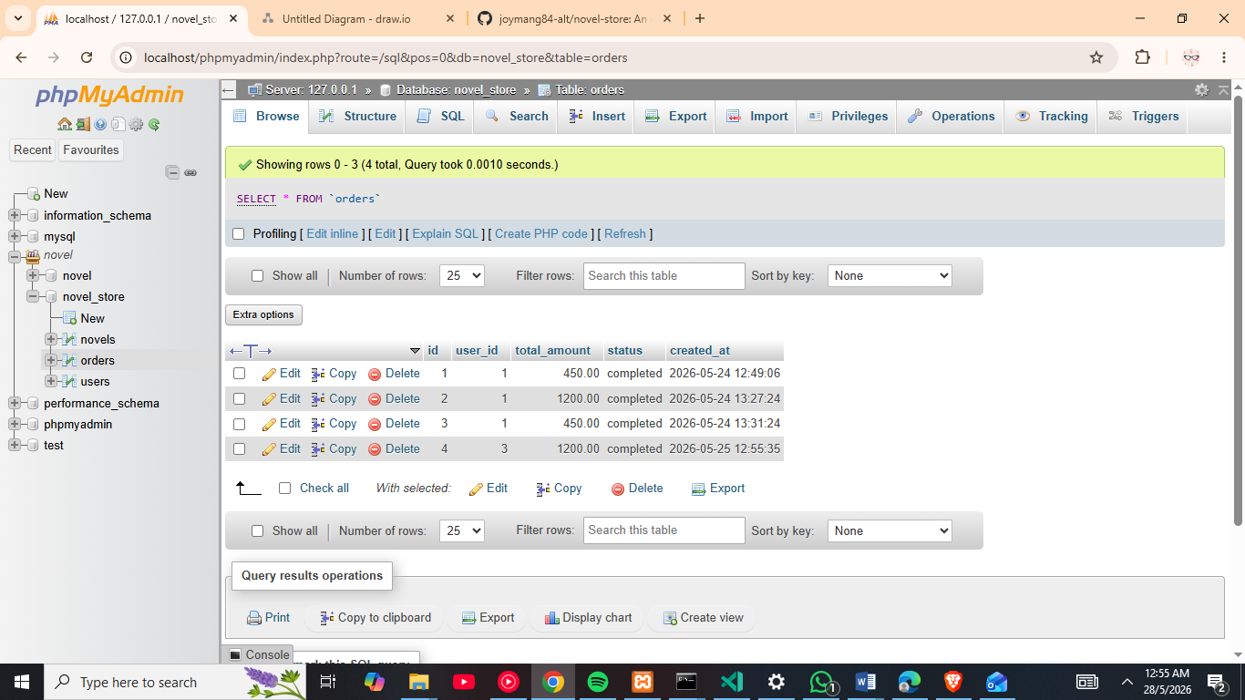

Users table
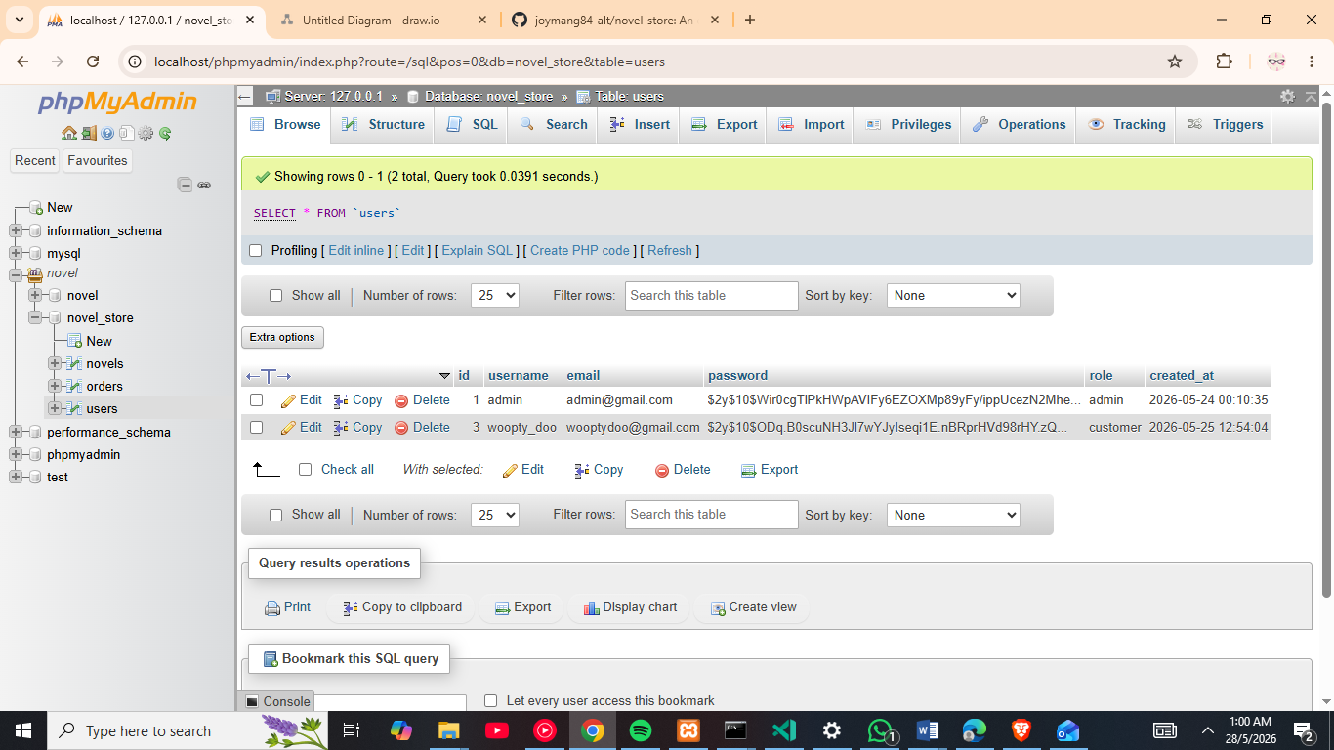

CRUD OPERATIONS

Create
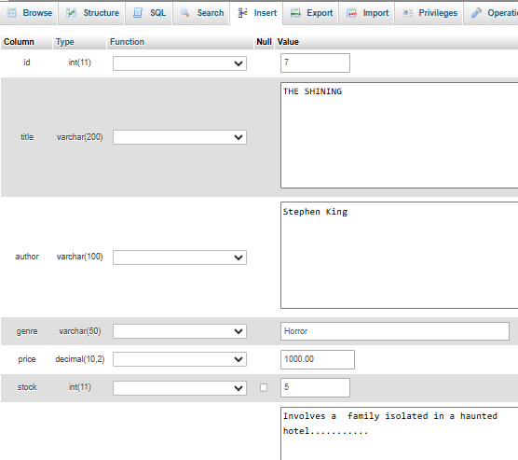

Update
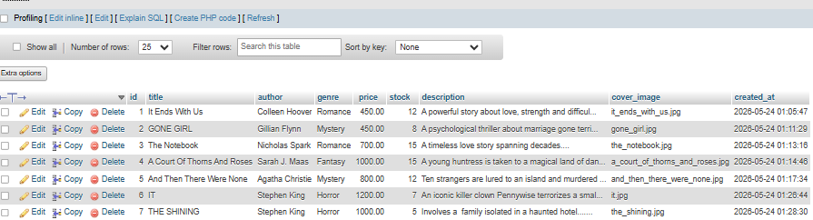

Login integration

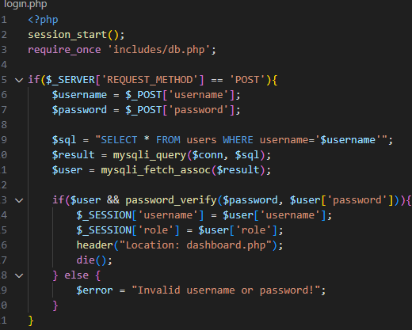

Login.php

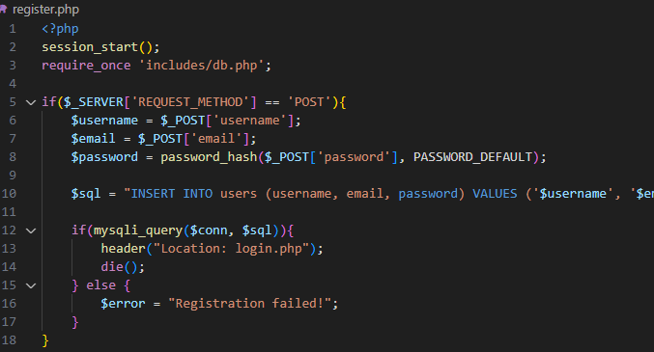

Register.php

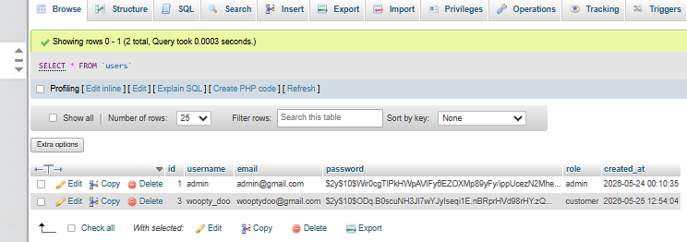

Sql query

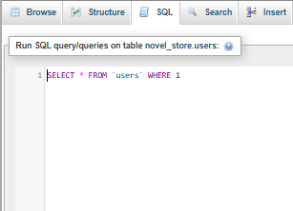 users query

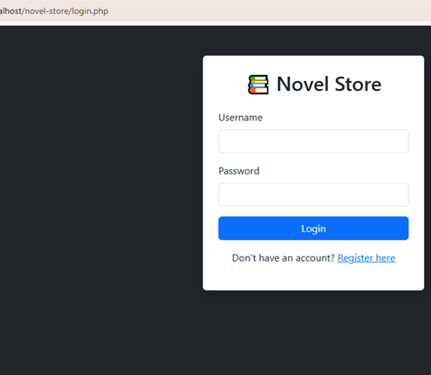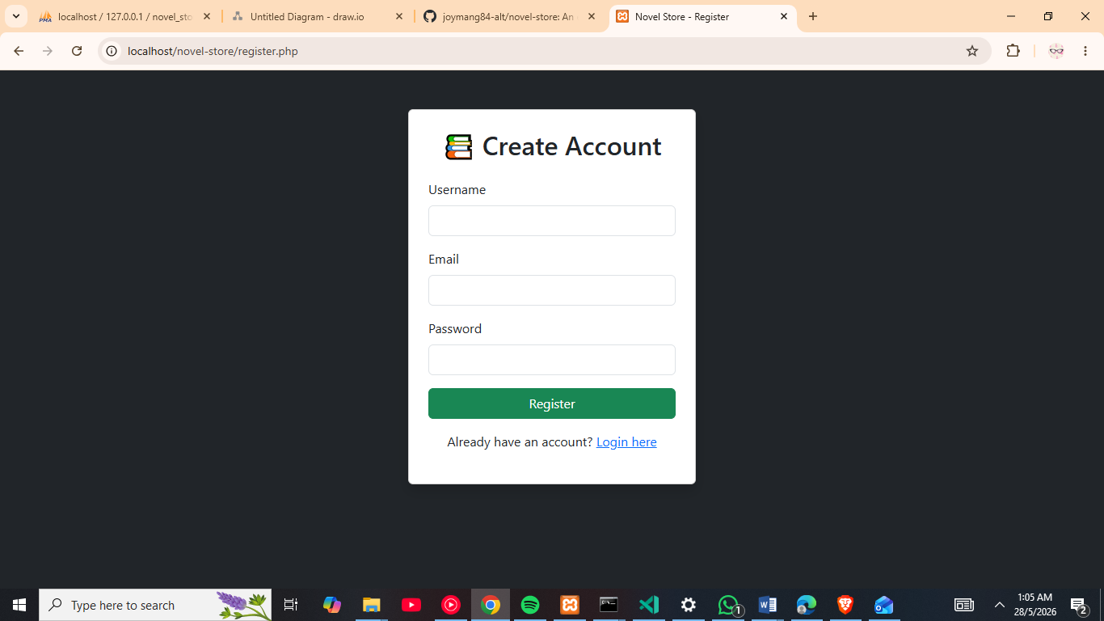
Login page Register page
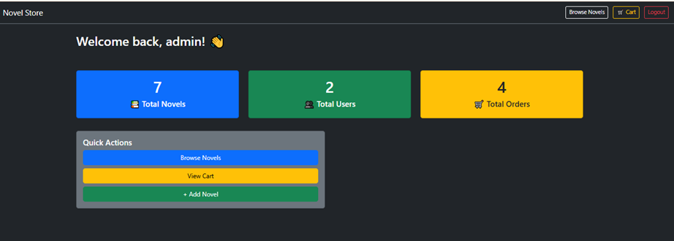
Dashboard

Novels catalog
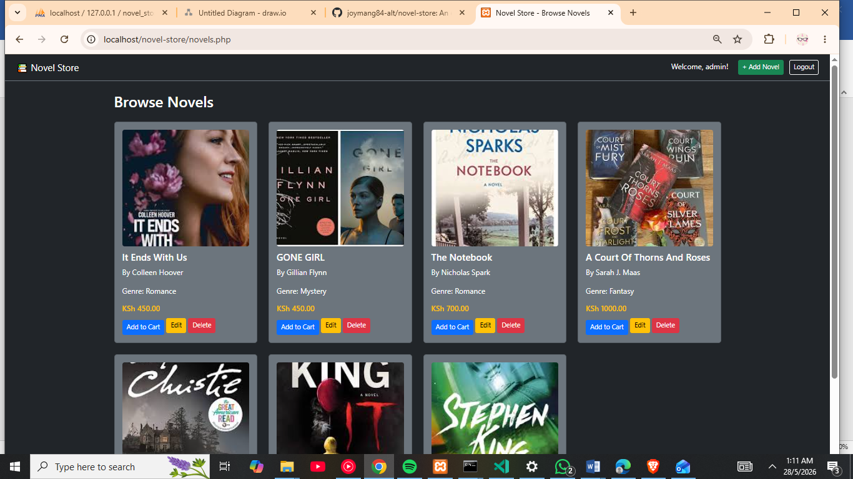
Add novel form
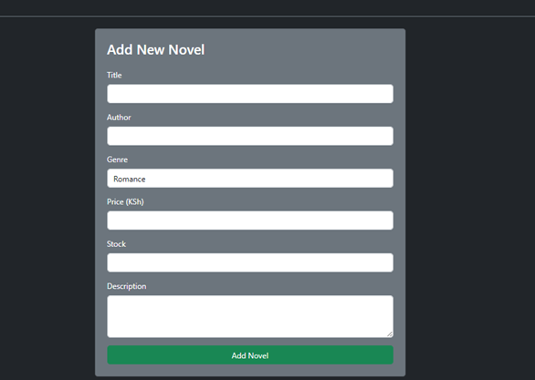
Cart page
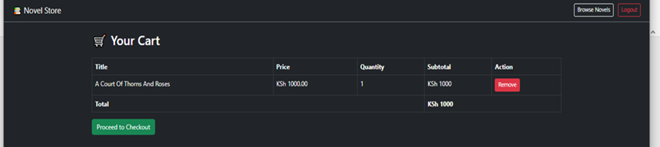
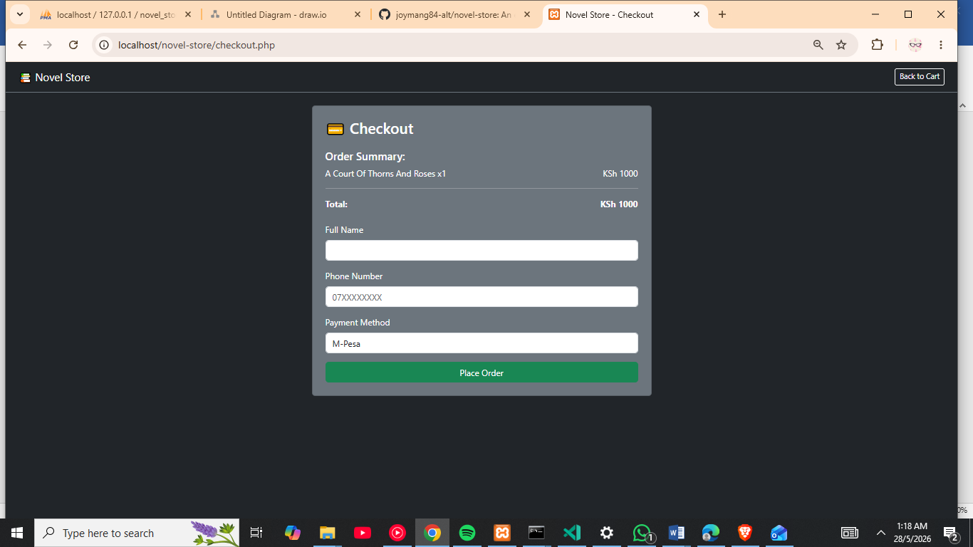
Checkout page
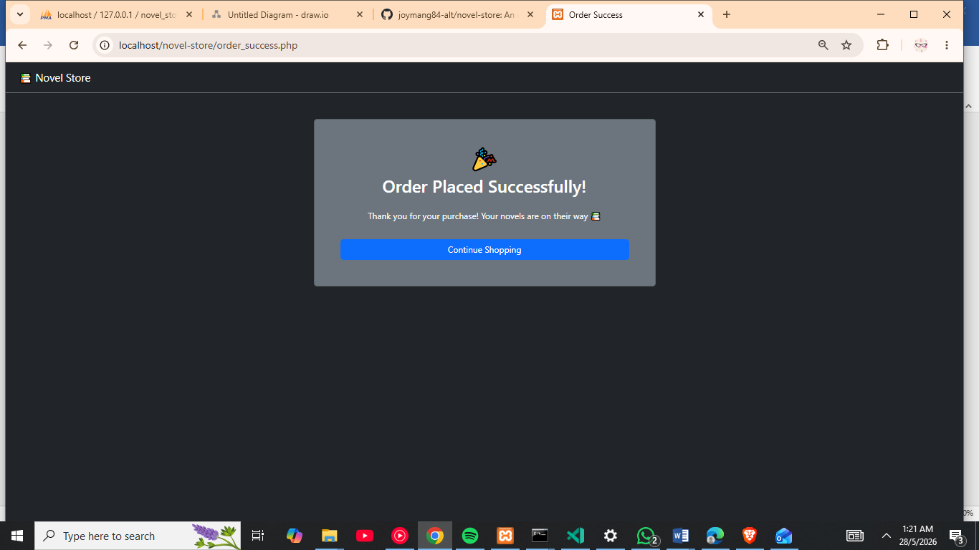
Order success page

